St. Peter Evangelical Lutheran Church

Hopewell Township, N.J.

(609) 466-0939 web site: stpeternj.org

pastor@stpeternj.org secretary@stpeternj.org

Rev. Jon Dunbar, Pastor (402) 641-4813

Chris Fusco, Music Director

Amy Van Hise, Admin Asst

Jennifer Garrow, Nursery School Director

Fourth Sunday after Pentecost

*July 6, 2025*

**Our mission:**

*to spread the Word of Salvation through Christ,*

*honor God, serve others, and grow in faith.*

**Welcome.** Jesus sent his disciples out “as lambs in the midst of wolves” (Luke 10:3), bearing in their bodies the sacrifice of His cross, by which “the kingdom of God has come near” (Luke 10:9, 11). Wherever He enters in with this Gospel, Satan is cast out and falls “like lightning from heaven” (Luke 10:18). Thus, we do not “boast except in the cross of our Lord Jesus Christ” (Gal. 6:14). Rejoicing in this Gospel, we “bear one another’s burdens” in love, according to “the law of Christ” (Gal. 6:2).

**Welcome guests!** We are delighted you are with us for worship this morning. Please introduce yourself to Pastor Steve, who is serving in the place of Pastor Jon today. Be sure to sign the guest book next to the front doors, and let us know how we can be of service to you. The order of service is printed in this bulletin starting on page 2. A cry room is available at the back left of the sanctuary for families with young children if there is a need.

**Communion Note:** We believe that our Lord gives into our mouths not only bread and wine but his very body and blood to eat and drink for the forgiveness of sins and to strengthen our union with him and with one another. Our Lord invites to his table those who trust his words, repent of all sin, and set aside any refusal to forgive and love as he forgives and loves us. Because unworthy reception of the sacrament can be harmful, those who are not yet instructed, are uncertain or doubtful, or hold to a different confession should speak to the Pastor before participating.

**PREPARATION**

**PRELUDE**

**CONFESSION AND ABSOLUTION**

P In the name of the Father and of the  Son and of the Holy Spirit.

C **Amen**

P If we say we have no sin we deceive ourselves and the truth is not in us. Let us confess our sin to God who is faithful and just and who has promised to forgive our sin and cleanse us from all unrighteousness.

*Silence for reflection on God's Word and for self-examination.*

P Most merciful God,

C **have mercy on us.**

**All:** **We confess that we have sinned against You in thought, word, and deed, by what we have done and by what we have left undone. We have not trusted You with our whole heart; we have not loved one another in deed and in truth. In Your compassion forgive our sin and so uphold us by Your Spirit that we may live and serve You in newness of life through Jesus Christ our light and truth. Amen.**

P With joy, I proclaim to you that Almighty God, rich in mercy, abundant in love, forgives you all your sin and grants you newness of life in Jesus Christ.

C **Thanks be to God!**

**SERVICE OF THE WORD**

**OPENING HYMN** 700 Love Divine, All Loves Excelling

**KYRIE**  *Lord, Have Mercy Mark 10:47*

Pastor: In peace, in peace,

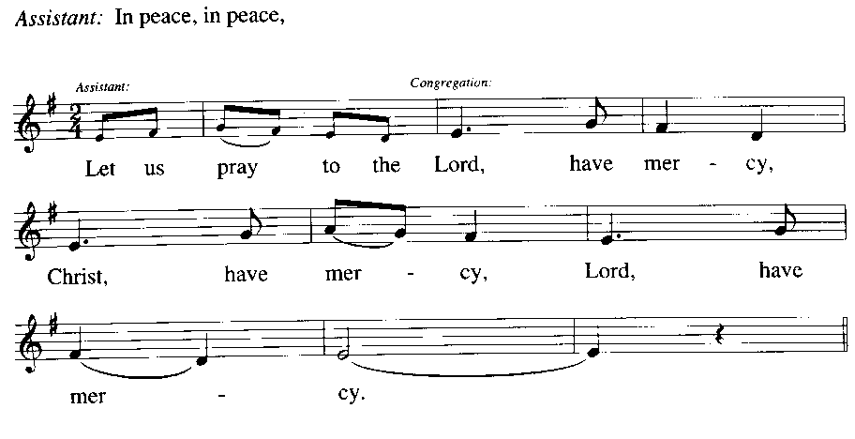

Pastor: For the Reign of God, and for peace throughout the world, for the unity of all… (Refrain)

Pastor: For your people here, who have come to give you praise, for the strength to live your Word… (Refrain)

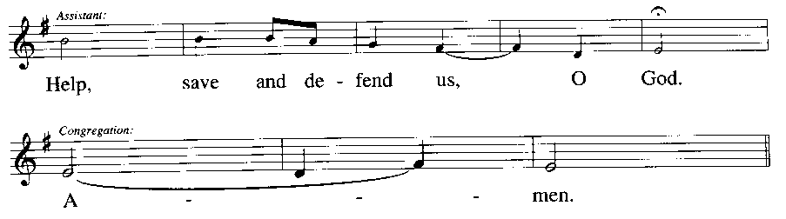

Pastor:

Cong:

**NOW THE FEAST**

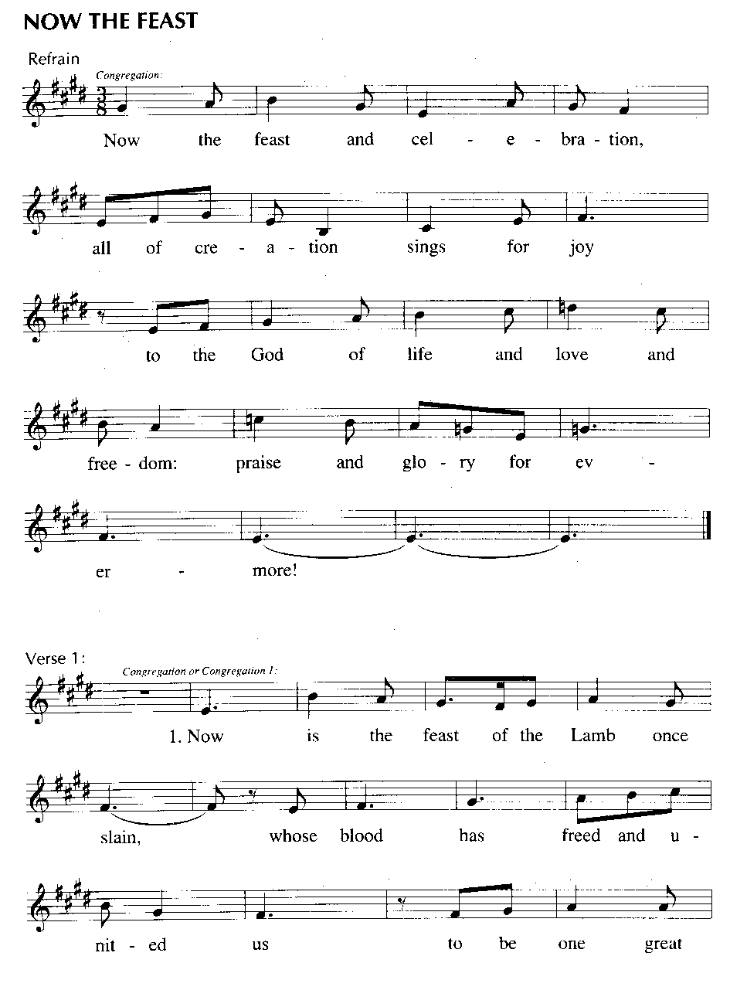

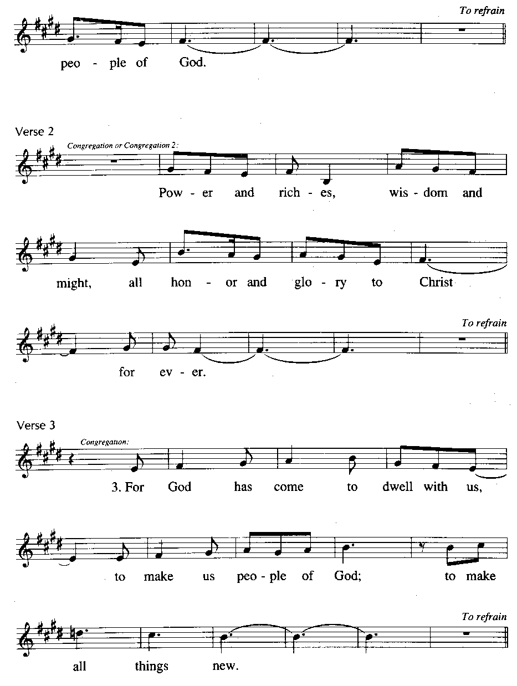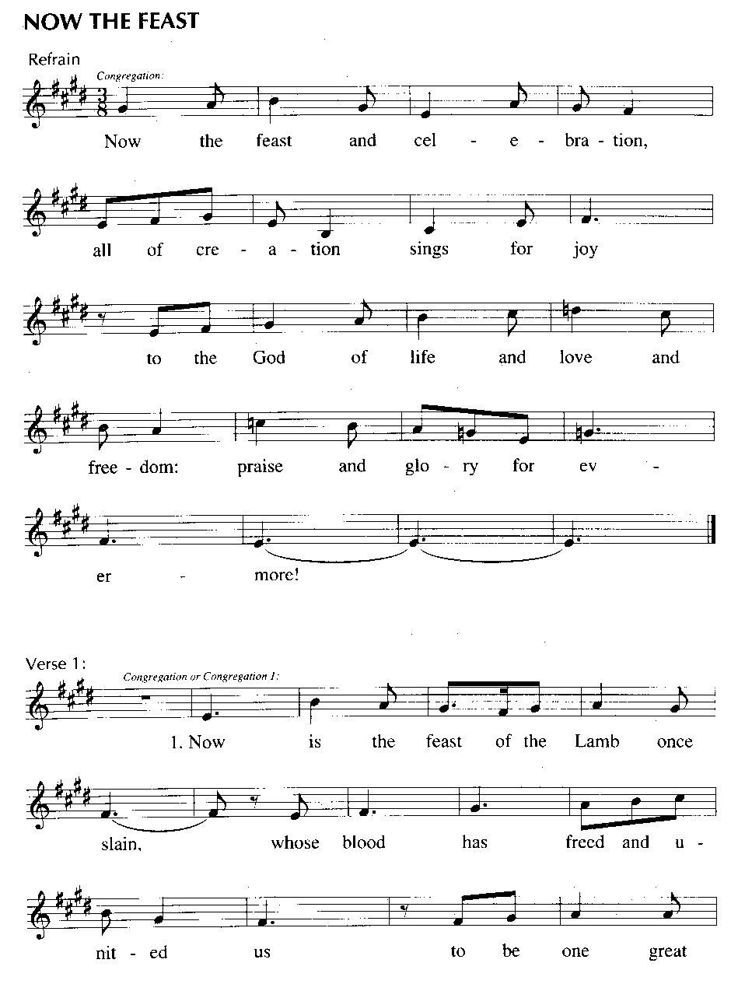

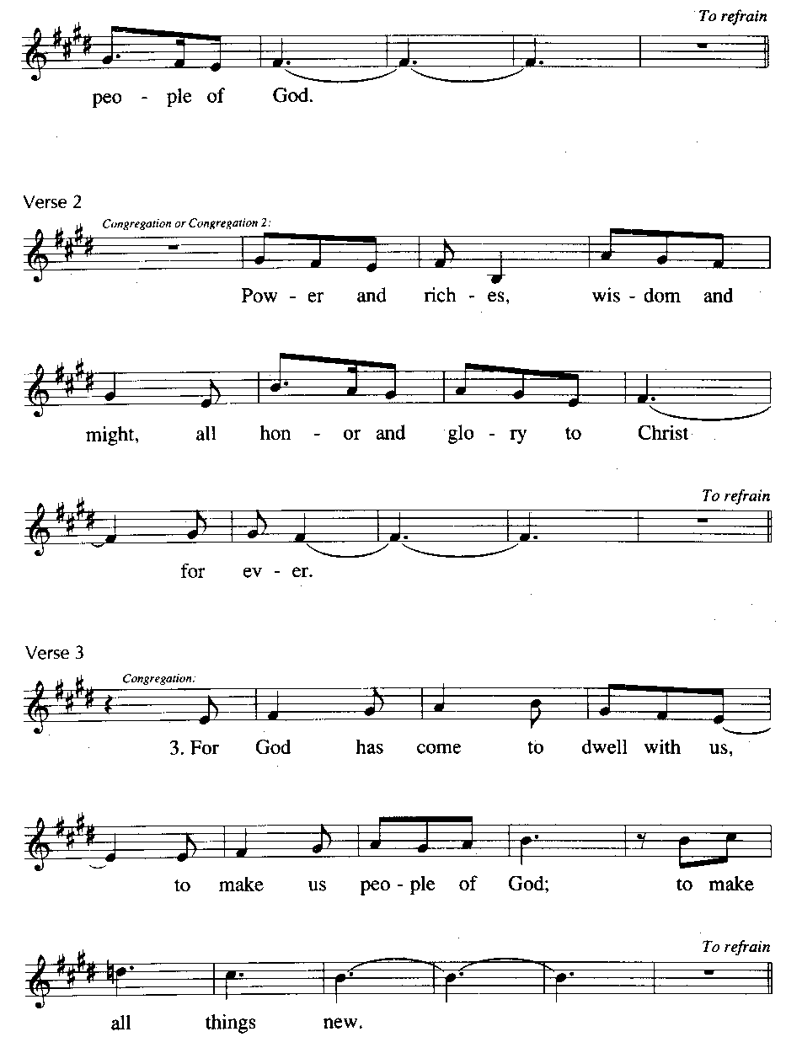

**SALUTATION and COLLECT OF THE DAY**

P The Lord be with you.

C **And also with you.**

P Let us pray.

Almighty God,

You have built Your Church on the foundation of the apostles and prophets

with Christ Jesus Himself as the cornerstone.

Continue to send Your messengers to preserve Your people in true peace

that, by the preaching of Your Word,

Your Church may be kept free from all harm and danger;

through Jesus Christ, Your Son, our Lord,

who lives and reigns with You and the Holy Spirit,

one God, now and forever.

C **Amen**

**OLD TESTAMENT READING:** Isaiah 66:10-14 (see back)

**PSALM 66** (spoken responsively by whole verse)

P: Shout for joy to God, all the earth;

**C: sing the glory of His name; give to Him glorious praise!**

P: Say to God, “How awesome are Your deeds!

So great is Your power that Your enemies come cringing to You.

**C: All the earth worships You and sings praises to You;  
     they sing praises to Your name.”**

P: Come and see what God has done:  
     He is awesome in His deeds toward the children of man.

**C: He turned the sea into dry land; they passed through the river on foot.  
 There did we rejoice in Him,**

P: who rules by His might forever, whose eyes keep watch on the nations—  
     let not the rebellious exalt themselves.

**EPISTLE:** Galatians 6:1-10, 14-18 (see back)

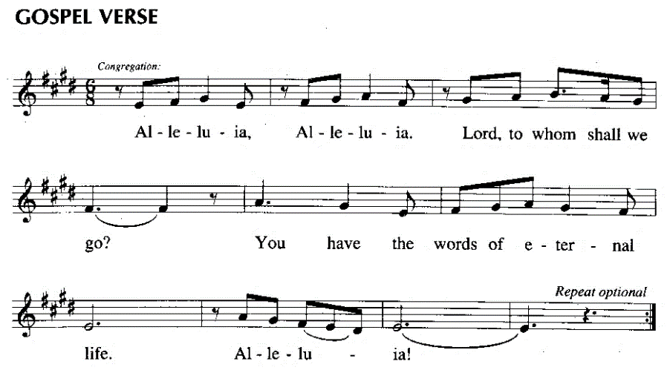**ALLELUIA VERSE:**

**HOLY GOSPEL**

P The Holy Gospel according to St. Luke, the 10th chapter.

C **Glory to You, O Lord.**

***Luke 10:1-20***

P This is the Gospel of the Lord.

C **Praise to You, O Christ.**

**NICENE CREED** (Inside the back cover of the hymnal.)

**HYMN OF THE DAY**  827 Hark, the Voice of Jesus Calling

**SERMON**

**PRAYER OF THE CHURCH**  *1 Timothy 2:1-4*

P …Lord, in Your mercy, C **hear our prayer.**

**Prayer Request List** (Names are placed on the list by request only.)

|  |  |  |
| --- | --- | --- |
|  | ***For comfort:***  The Landis Family death of Bill Teschke  The Long Family death of Tim Steimle  The Luccarelli Family death of Mike deDufour  The Benesch family death of son Nico Van Beuzekom |  |
|  |  |  |

***For those with health concerns:***

|  |  |  |  |  |
| --- | --- | --- | --- | --- |
| Tom Dorsett | Jim Yost | Carla Behnfeldt | Grant | Sid |
| Hank Van Beuzekom | Donna Poucel | Lolly Hoagland | Noah | Susan |
| Fran Byrzkinsy | Pete Serone | John Tarlo | Greg | Chris |
| Claudia Zucker | John O’Neil | Claire Haenisch | Brennan | Rose |
| Gordon Anderson | Carl Lauricella | Terry Farley | Claire | Beverly |
| George DiCostanzo | Freda Potts | Rick Wright | Barbara | Mary |
| Katherine Eccleston | Kay Compton | Ursula Chirico | Zane | Joanne |
| Linda Wright | Pat Dietz | Phil Unetic | Anna | JoAnne |
| Kay Compton | Pat McCann | Mary Cobriere | Irene | Kristin |
| Monica Benesch | Drew Klesat | Marge Keen | Bill Akers |  |
|  |  |  |  |  |
|  |  |  |  |  |

***For those with cancer:***

|  |  |  |  |  |
| --- | --- | --- | --- | --- |
| Keith Watson | Aaron Kline | Terry Dunbar | Joan Rawls | Trudy |
| Rich Knechel | Karen Shevchuk | Gerry Campbell | Mary Anne | Lance |
| Carol Tezla | Steve Saumsiegle | Brad Hoppe | Dave Bond | Linda |
| Kim McCollough | Nancy Gilliand | Aunt Jean | Judy Bacorn | Jerry |
| Andrea(Andy) Hoteling | Kaleigh Moore | Sally Ashmen | Dora | Lynn |
| Rich deDufour | Logan Mattessich | Frank Cignus | Doris | Dana |
| Jane Fry | Frumi C | Rosalie Reinbacher | Barbara | Jason |
| Barbara Howard |  |  |  |  |

***For those serving in the armed forces:***

|  |  |  |  |  |  |
| --- | --- | --- | --- | --- | --- |
| LJ Lupinacci | Carrick Porter | Emily Arndt | Jake Grube | Jim Buckman |  |
| Daniel Gewecke | James Bannon | Harper Usiskin | Jesse Sowell | Mike Bahney |  |

***For St. Peter Lutheran Nursery School:***

For staff and families of the school For enrollment ’25-‘26

***For those with needs around the world:***

|  |  |
| --- | --- |
| Persecuted brothers and sisters in Christ | For protection, strength, comfort, spread of Gospel |
| Government officials and people of our nation | For peace, unity, safety, and wisdom |
| Those coping with disasters | For provision and help |
| Those in need of employment | For provision of jobs |
| Wars in Europe and Middle East | For peace, forgiveness, and guidance |
| Family of Olga Nichols living in Ukraine | For health, safety, and provision |
| Those who are traveling | For safety and provision |
|  |  |

**Birthdays:**

Riley Robinson July 7 PJ Grube July 9 Mark McAllister July 10

**Anniversaries:**

Tom and Christine Dorsett July 8

**GATHERING OF THE OFFERING AND OFFERTORY**

**Instrumental Offertory**

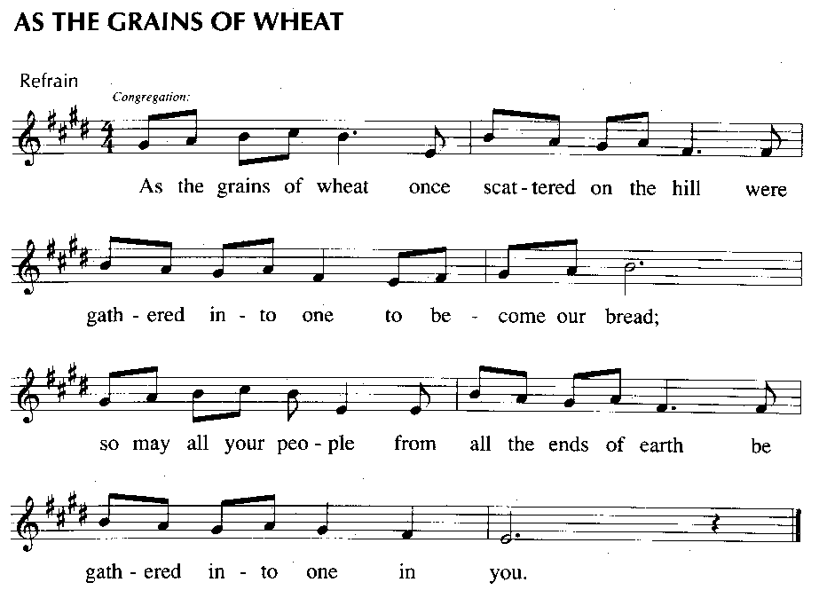

**Congregational Offertory:**

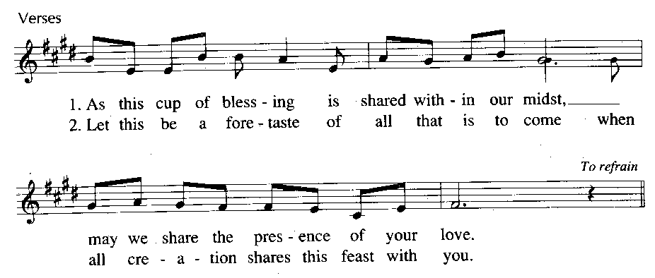

**SERVICE OF THE SACRAMENT**

**PREFACE**

P The Lord be with you. C **And also with you.**

P Lift up your hearts. C **We lift them to the Lord.**

P Let us give thanks to the Lord our God. C **It is right to give Him thanks and praise.**

P It is truly good, right, and salutary…

C **Amen.**

**SANCTUS**  *Holy, Holy, Holy (LSB p. 208) Isaiah 6:3; Matthew 21:9*

C **Holy, holy, holy Lord God of Sabaoth adored;**

**Heaven and earth with full acclaim shout the glory of Your name.**

**Sing hosanna in the highest, sing hosanna to the Lord;**

**Truly blessed is He who comes in the name of the Lord!**

**LORD’S PRAYER** *Matthew 6:9–13*

**THE WORDS OF INSTITUTION** *Matthew 26:26–28; Mark 14:22–24; Luke 22:19–20; 1 Corinthians 11:23–25*

**PAX DOMINI** *The Peace of the Lord John 20:19*

P The peace of the Lord be with you always.

C **And also with you.**

**AGNUS DEI**  *Lamb of God*

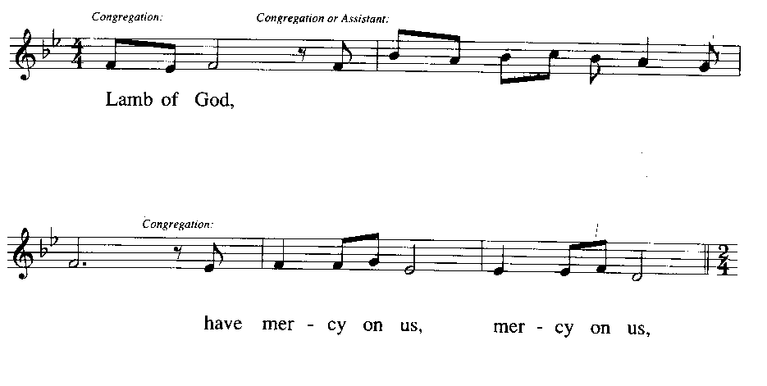

**you take a – way the sin of the**

**you are the bread of life for us**

**you are the way of jus – tice and**

**world:**

**all:**

**peace:**

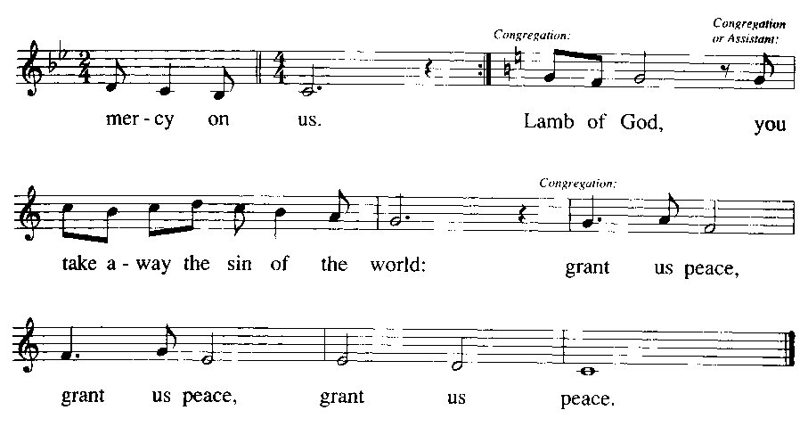

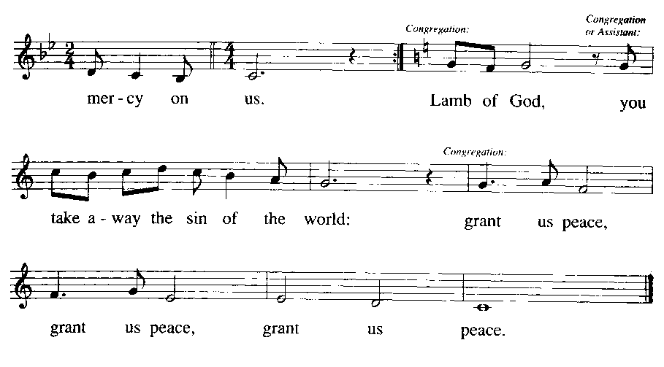

**DISTRIBUTION HYMN**  570 Just as I Am, without One Plea

**POST-COMMUNION PRAYER**

**BENEDICTION**



**CLOSING HYMN** 965 God Bless Our Native Land

**ANNOUNCEMENTS**

**DISMISSAL**

P: Go in peace! Serve the LORD!

**C: Thanks be to God!**

**POSTLUDE**



** Announcements – Week of July 6, 2025**

**Need assistance? The Church Office is staffed each week**

**\*MON, TUES and WED from 1:00 - 3:00\***

***Worship, Sunday School, and Bible Study***

**Welcome!** Serving in worship today are: Jim Steimle (Communion Assistant and Reader), Sadie Bloom (Acolyte), Dave deDufour (Usher), Lesley deDufour (Live-streaming), Amy Van Hise (Communion and coffee set-up and clean-up).

**Today’s service will be live streamed** on You Tube at the following link: <https://youtube.com/live/sye2aiLnpmA> If you miss the service live, watch it whenever you like! The services are also posted to the [church’s website](https://stpeternj.org/).

**Bible studies and Sunday School on break for the summer.** Wednesday and Sunday morning bible studies and children’s Sunday School are on break now through the month of August. You're encouraged to continue growing in God's Word by using Portals of Prayer or another favorite devotional.

**No Discussion Group today.** There will be no discussion group today after the service since Pastor is away on vacation.

**Weekly Schedule**:

SATURDAY-FRIDAY (6/5-11) Pastor on Vacation

SUNDAY (6/13) 9:30a Worship; 11:00a Discussion Group

***Men’s, Women’s, Senior’s, Youth and Family Ministry***

Spring Clean-up Day - Saturday April 12th 8:30am till Noon. Bring your shovels, rakes, clippers, gloves, wheelbarrows and cleaning supplies to help spruce up the property before Easter. We will be

working inside and outside the building. If you can't make it on Saturday a task list will be posted on the bulletin board for anyone who wants to work  during the week. A light breakfast will be served starting at 8am.

Spring Clean-up Day - Saturday April 12th 8:30am till Noon. Bring your shovels, rakes, clippers, gloves, wheelbarrows and cleaning supplies to help spruce up the property before Easter. We will be

working inside and outside the building. If you can't make it on Saturday a task list will be posted on the bulletin board for anyone who wants to work  during the week. A light breakfast will be served starting at 8am.

Spring Clean-up Day - Saturday April 12th 8:30am till Noon. Bring your shovels, rakes, clippers, gloves, wheelbarrows and cleaning supplies to help spruce up the property before Easter. We will be

working inside and outside the building. If you can't make it on Saturday a task list will be posted on the bulletin board for anyone who wants to work  during the week. A light breakfast will be served starting at 8am.

**Operation Christmas Child**. Pick up the gold sheet on the narthex table with a list of the things we still need before the **July 31 packing party**. Place in the box in the narthex. There is also a jar in the narthex to make donations toward the shipping costs - thanks so much!

**Prayer Chain**. The Prayer Chain is ready to receive your prayer requests. Simply call Barbara Greenberg at (609) 512-1928 to start or update a prayer.

**The Prayer Shawl/Lap Blanket Ministry**. Join us in making special blankets to bless those in need of comfort or in celebration of a life event! Please speak with Barbara Greenberg at (609) 512-1928.

***Service and Other***

**Lambertville Food Pantry**. Please grab some non-perishable items at the grocery store to add to our food pantry collection box in the narthex. July’s theme is Paper products: paper towels, facial and toilet tissue.

**Faithfulness Repor**t:

Attendance 6/29: 50 Gen Fund (plate and elec): $2125 Flowers: $25

**Flowers**. If you would like to have flowers placed on the altar in honor of someone, in thanksgiving for God’s grace, or for a special occasion, there is a sign-up sheet on the bulletin board to do so. Suggested donation is $25. You may take the flowers home following the service on the day you select.

**Flowers are placed on the altar in honor of Christine and Tom Dorsett’s 30th anniversary!**

**Website and Facebook**. Come online to check us out! Our website is at [www.stpeternj.org](http://www.stpeternj.org), and our Facebook page is Saint Peter Lutheran Church – the link is: <https://www.facebook.com/pages/Saint-Peter-Lutheran-Church/337705479662612>.

**St. Peter YouTube Channel**. Increase St. Peter's online visibility by liking and subscribing to our [YouTube channel](https://www.youtube.com/@saintpeterlutheranchurch375) (where we live-stream and record our worship services and Wednesday Zoom bible studies. It is linked to our church website, or go to YouTube and search "Saint Peter Lutheran Church".

**Other Important web links:**

The Lutheran Church – Missouri Synod [lcms.org](http://www.lcms.org/)

NJ District LCMS [njdistrict.org](http://www.njdistrict.org/)

LCMS World Relief and Human Care lcms.org/ca/worldrelief

The “Lutheran Hour” Broadcast [lhm.org](http://www.lhm.org/)

*(A note from Chris)*

*Dear Friends of St. Peter Church,*

*Please know of my heartfelt thanks for the beautiful recognition and reception on June 29th in honor of my 10th anniversary as your organist . The kind words shared at the close of the service, the thoughtful and generous gift, and the warm fellowship during the reception were all deeply moving.*

*I was especially touched by the choir’s special anthem—what a meaningful and memorable tribute.*

*It has been, and continues to be, a true blessing for Trish and me to be of service and to share in the musical and spiritual life of our community. Thank you for your kindness, your support, and continuing to welcome me as a companion in worship these past ten years and in the future. I am truly blessed.*

*With gratitude and blessings,*

*Chris Fusco*

