St Peter Lutheran Church
Sanctity of Human Life Sunday
Prayer Ministry Team – Movie Night
Friday, January 17th @ 6:15 – 8:30 PM
Feature: Unplanned (Mature audience viewing)
The issue of abortion also known as a Women’s right to choose (Pro-Choice) is one that has divided this nation for many, many years. The movie is one person’s account of what is going on inside of the abortion issue.
The movie will be difficult to watch but necessary to watch to better understand the controversies surrounding Planned Parenthood and abortions.

. on, no one will leave this film unmoved by Abby’s journey.
As one of the youngest Planned Parenthood clinic directors in the nation, Abby Johnson was involved in upwards of 22,000 abortions and counseled countless women on their reproductive choices. Her passion surrounding a woman's right to choose led her to become a spokesperson for Planned Parenthood, fighting to enact legislation for the cause she so deeply believed in. Until the day she saw something that changed everything.

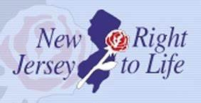
New Jersey New Right to Life Invites you to Join us as we Rally for Life
WEDNESDAY - January 22, 2020,
47th Anniversary of the Roe v. Wade U.S. Supreme Court Decision
State House Annex (Outside), 145 West State Street, Trenton, NJ
11:00 A.M. to approximately 1:00 P.M.
Rally info @ njrtl.org or call1.732.562.0562

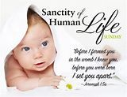
Movie Night Location: Corner of Routes 518 & 579
Hopewell Township, NJ
Phone: (609) 466-0939

